

Faculty of Applied Sciences  
Bachelor of Science in Computing

**COMP413 Enterprise System and Application Development**Academic Year 2022/23

|  |  |
| --- | --- |
| Project Assignment | |
|  |  |
| Student ID: | P1908345 |
| Student Name: | Jane Liu |
|  |  |
| Submission Date: | 04/12/2022 |

# Introduction

In recent year, people have less chance than before to go to theatres to watch movies due to the Covid-19. In contrast, they place more emphasis on finding online movie rental services. To fulfil people’s needs for this service, a website for movie rental is designed and developed in this project.

## Domain Description

This project is about online movie rental services. From the perspective of content, this project can be divided into the following two parts:

* **User**: this part contains some basic information about users including emails, first names, last names, and passwords.
* **Movie**: this part contains some basic information about movies including title, description, image URL, year, genre, leading actor, studio, director, length, rental price, cost production and estimated box-office revenue.

## High-Level Function Description

According to the domain defined above, this project should have the following high-level functions:

* **User**: register, login.
* **Movie**: list all movies, list details of a movie, add a new movie, edit a movie, delete an existing movie, and search a movie.

## Summary

This report is analysed as following: Chapter 2 introduces design ideas of this project. Chapter 3 shows the user interface screenshots of this project. Chapter 4 is the overall conclusion of this project.

# Design

In this chapter, the design ideas of this project are introduced hierarchically. In high level design section, the general technical approach and the frameworks used are defined. In low level design section, the sitemap, class diagram, ER diagram and data definition language scripts are introduced separately.

## General Technical Approach

This project follows the model-view-controller (MVC) software architecture pattern. In other words, this project is divided into three parts – model (the database and the interactive actions with the database), view (user interfaces handling users’ inputs and presenting the results) and controller (accepting inputs and converting them into commends for the model or view). By using this software architecture pattern, different parts of this project can be developed more independently, which is convenient for future expanding or maintaining.

This project is further separated into two parts – frontend and backend, putting the view part into frontend and the model and controller parts into backend. Due to separating into frontend and backend, the project is modularity and has better scalability and resource optimization.

## Key Technical Design Decision

Since this project is frontend and backend separated, different frameworks are used in these two parts:

* **Frontend**:
* **Vue.js**: This framework is used to handle users’ inputs and present the results to users. The reason why choosing this framework is that it is a lightweight but high-performance framework in web development, and it is easy to learn.
* **Bootstrap**: This framework is used to have a nice-looking user-interface. This framework is chosen because there are abundant ready-made designs, and it is convenient to use them directly.
* **Backend**:
* **Spring Boot**: This framework is used to handle user’s requests, interact with database, and send back the responses. This framework is chosen because it is easy to develop and it reduces development time.

## Project Structure

The whole project structure is shown in Figure 1. To be more specific, the frontend folder represents the frontend, while the main folder represents the backend. In the frontend part, Vue files under frontend folder are used to represent the view part in MVC pattern. In the backend part, the java files under controller folder and service folder are used to represent the controller part in MVC pattern. And the java files under repository folder, dto folder and model folder are used to represent the model part in MVC pattern.

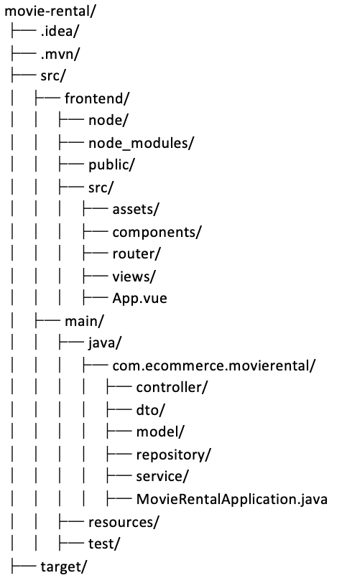

Figure 1 Project structure

## Sitemap

This section introduces the frontend (view) in detail by using sitemap (Figure 2).

Figure 2 Sitemap

## Class Diagram

This section introduces the backend (model and controller) in detail by using class diagram (Figure 3). (This class diagram is generated by IntelliJ IDEA. There are two block types in this diagram – Class (C) and Interface (I). The block can be divided into three parts – constructors, fields and methods. And in every block, the green lock represents public (‘+’) and the red lock represents private (‘-’).)

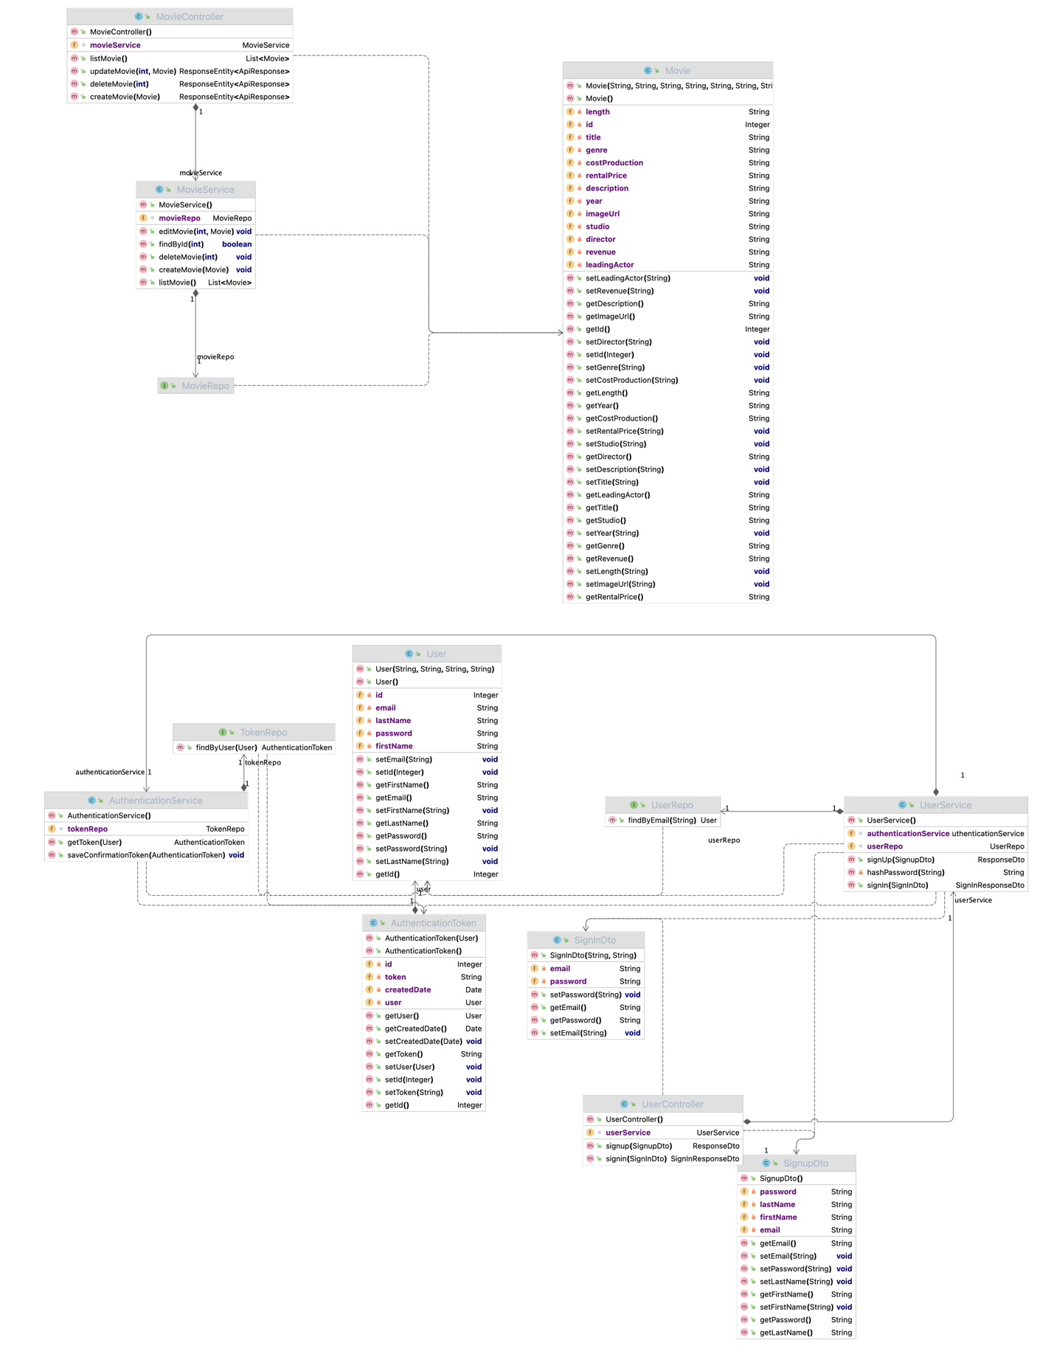

Figure 3 Class diagram

## ER Diagram

This section shows the structures of database by using ER diagram (Figure 4).

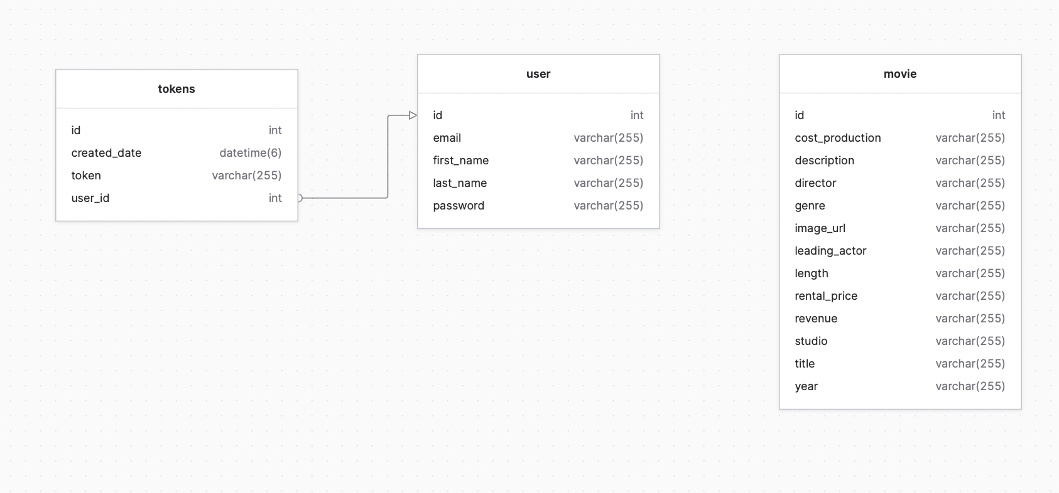

Figure 4 ER diagram

## Data Definition Language Scripts

This section defines the data definition language scripts (Figure 5).

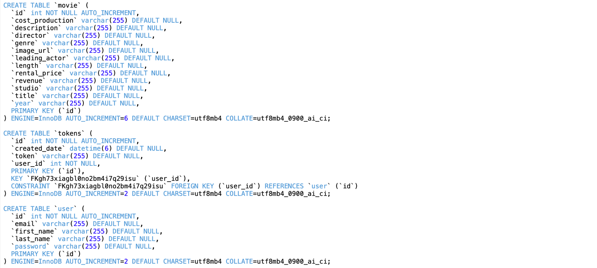

Figure 5 Data definition language script

# User Interface Screenshot

This chapter shows the user interface screenshots. It can be divided into two parts – the functions about users (login and register) and the functions about movies (list all movies, list details of a movie, add a new movie, edit a movie, delete an existing movie, and search a movie).

## Functions about Users

### Register

Users can press the sign up button in account list in the navigation bar and then they will see the web page for creating account (Figure 6).

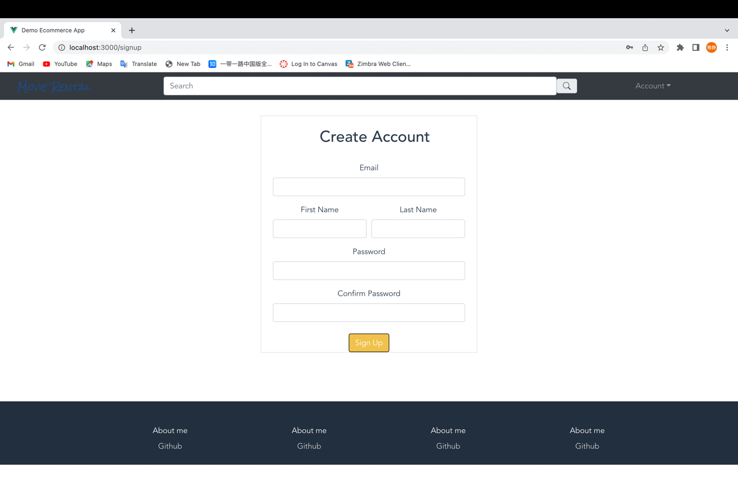

Figure 6 Create account

After inputting the information (Figure 7), users press the sign up button, and then they will go to the home page and see an alert (Figure 8).

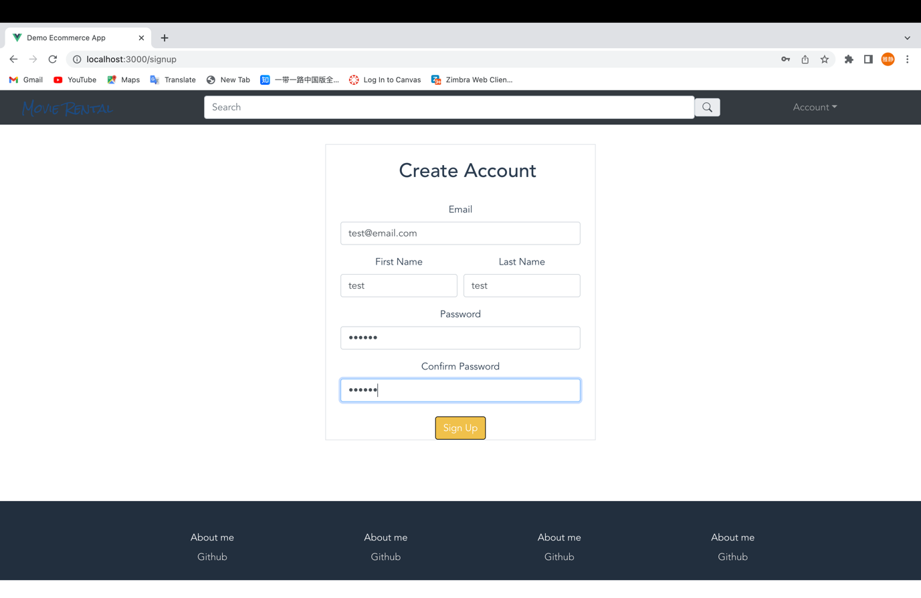

Figure 7 Input the user information

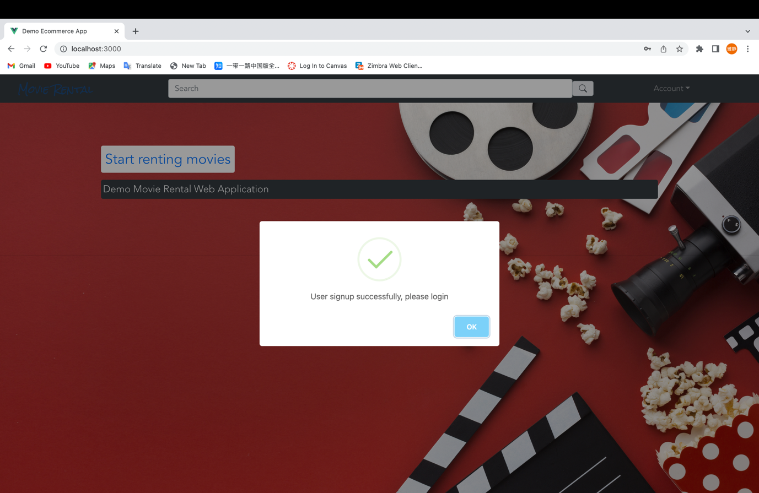

Figure 8 Home page and alert

The user information is stored in database and the password is handled by hash algorithms MD5 (Figure 9).



Figure 9 Database record

### Login

Users can press the sign in button in account list in the navigation bar and then they will see the web page for login (Figure 10).

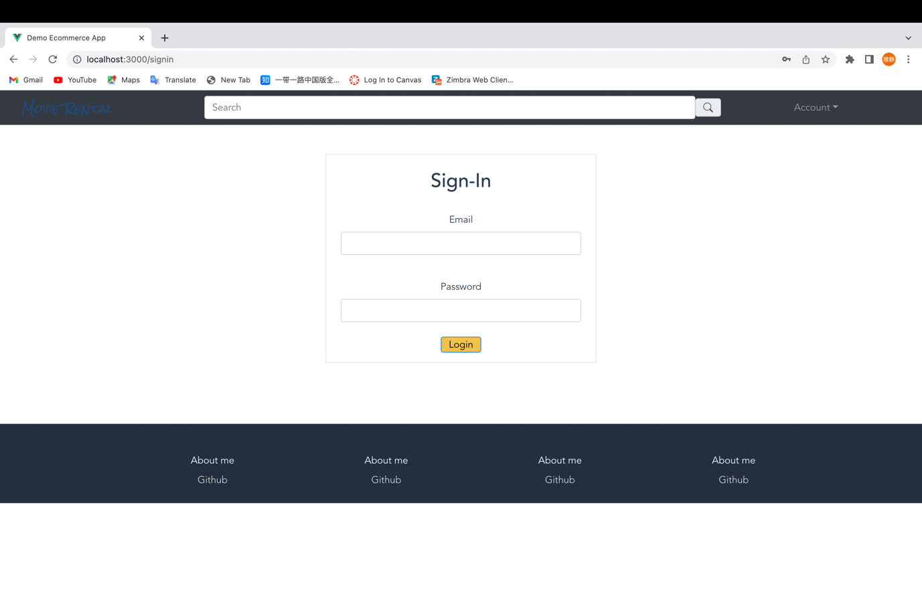

Figure 10 Login

After inputting the information (Figure 11), users press the login button, and then they will go to the home page and see an alert (Figure 12).

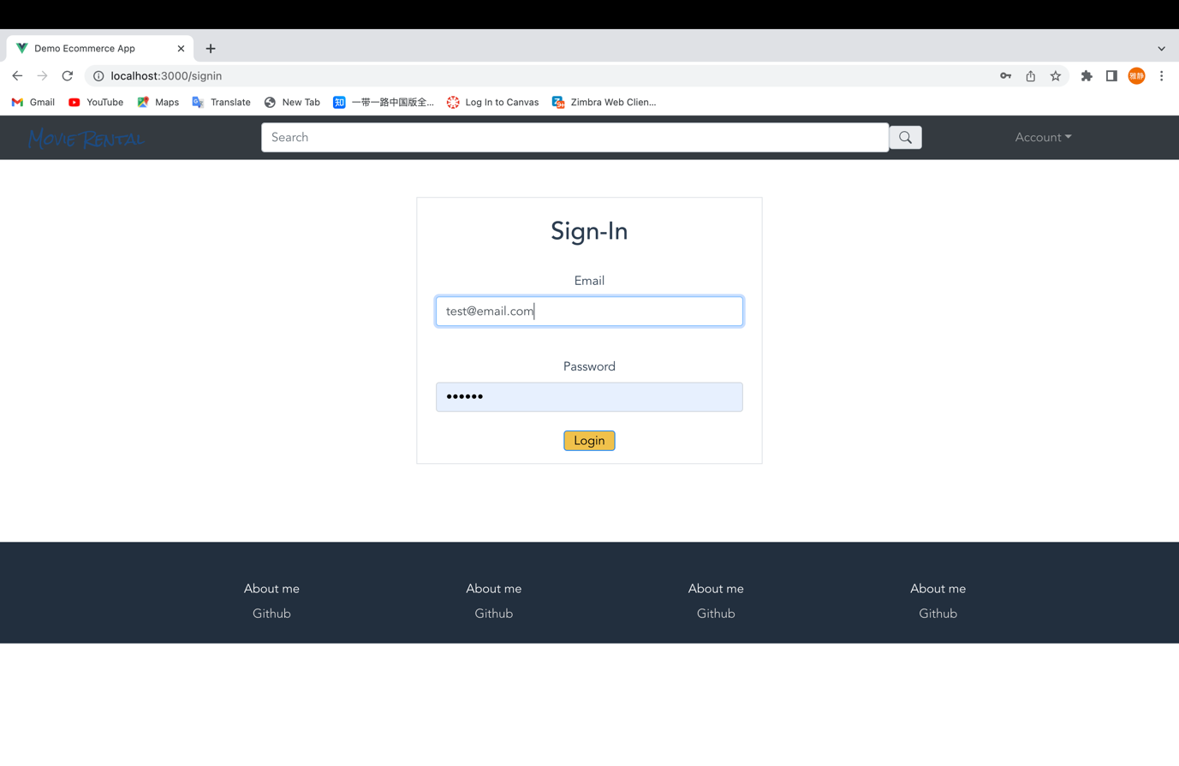

Figure 11 Input information

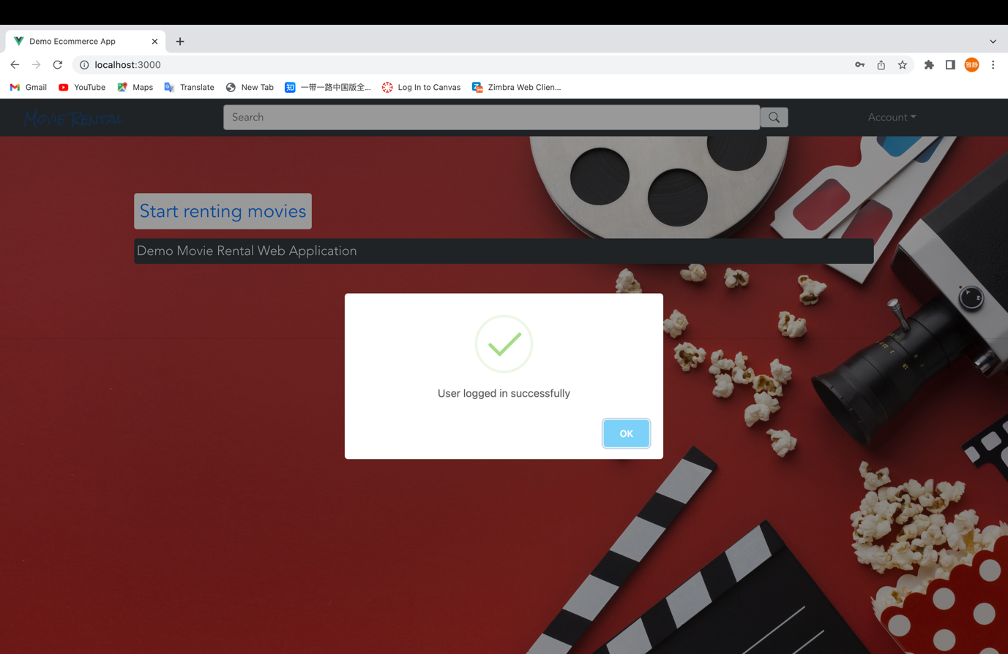

Figure 12 Home page and alert

## Functions about Movies

### List All Movies

In the home page (Figure 13), users can slide the web page down or press the button ‘start renting movies’ to see all the movies (Figure 14).

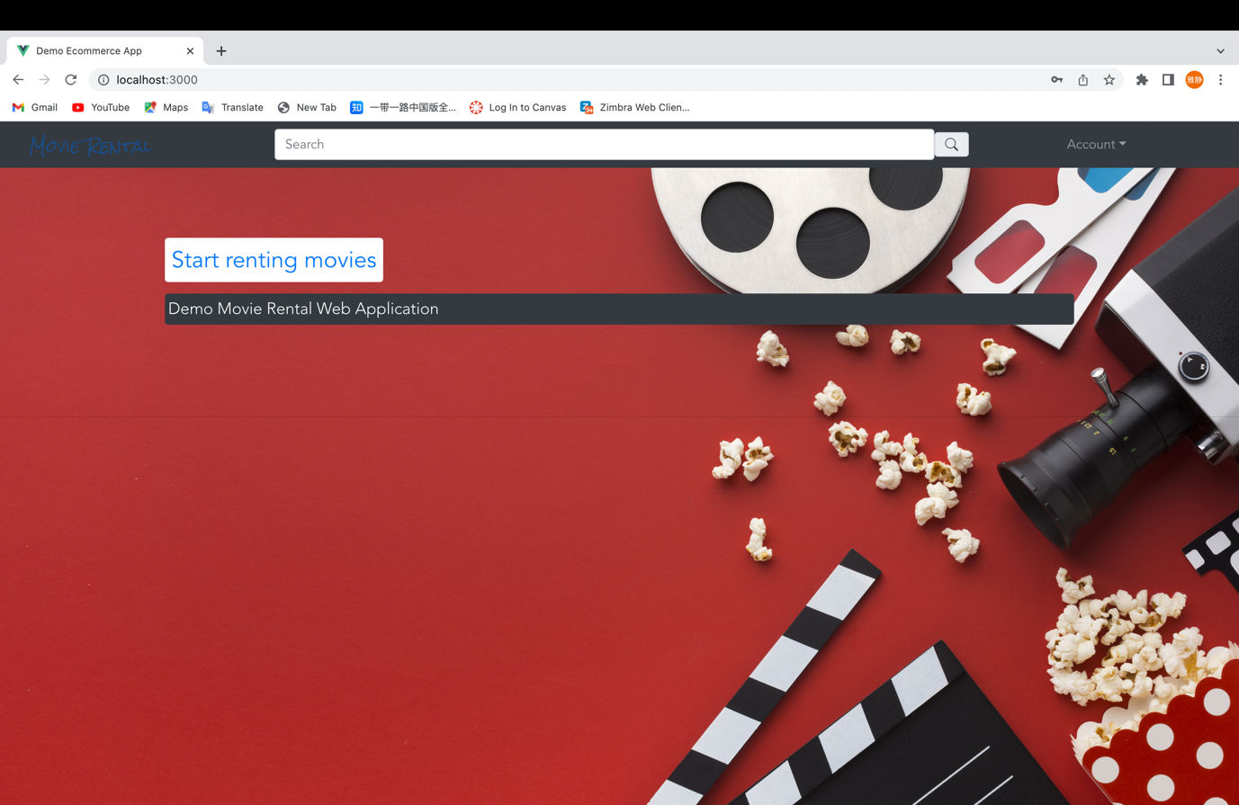

Figure 13 Home page

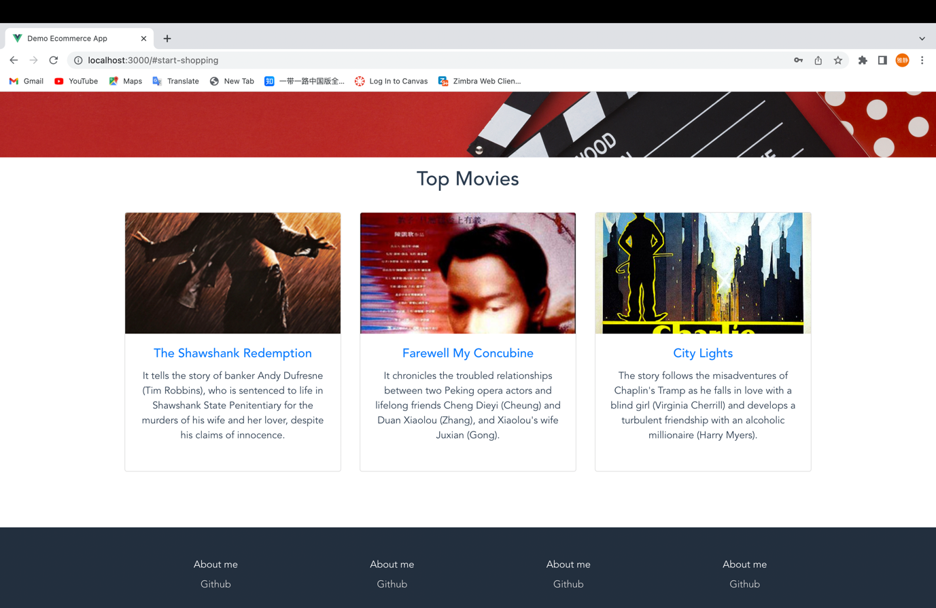

Figure 14 List all movies

### List Movie Details

After seeing all the movies, users can press the title of one movie and then they will see the movie detail page (Figure 15).

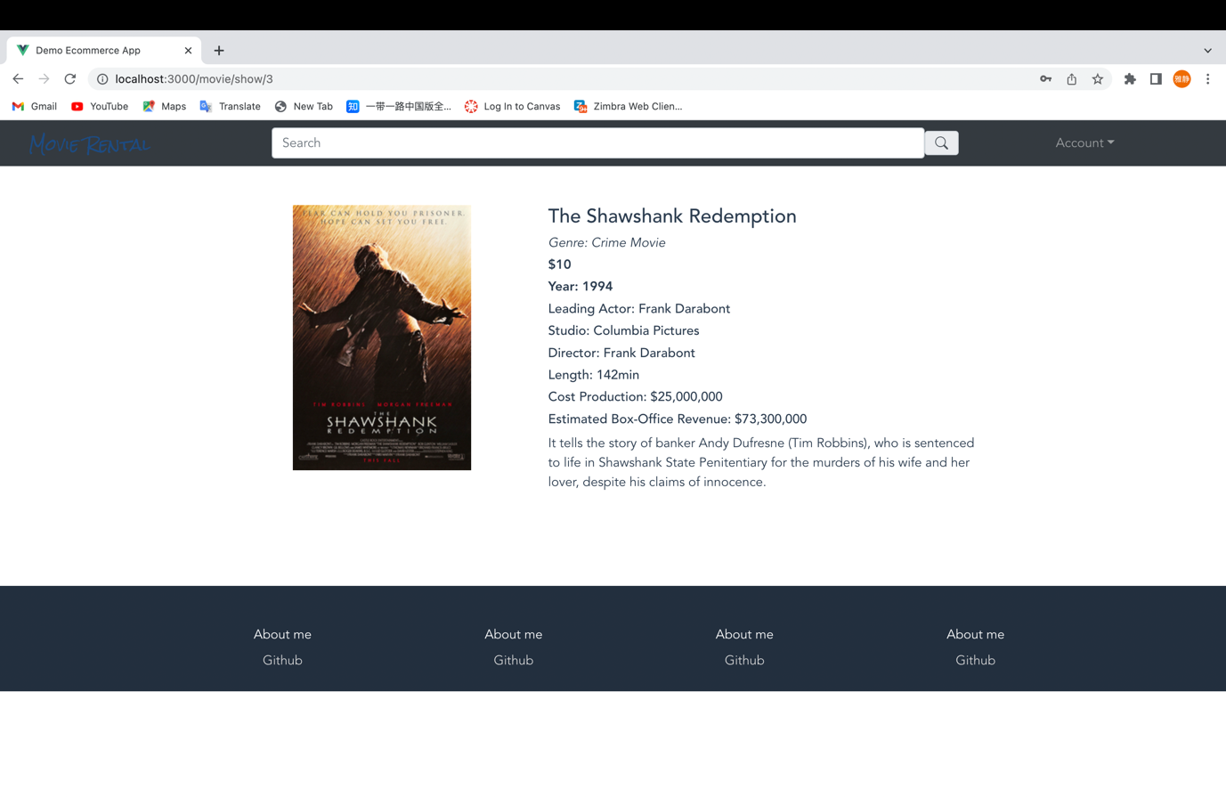

Figure 15 Movie Detail Page

### Add New Movie

Users can press the admin in account list in the navigation bar, and then they will go to the admin page (Figure 16). They can press the ‘admin movie’ button to go to movie page (Figure 17). They can press the ‘add movie’ button in this page and go to add movie page (Figure 18).

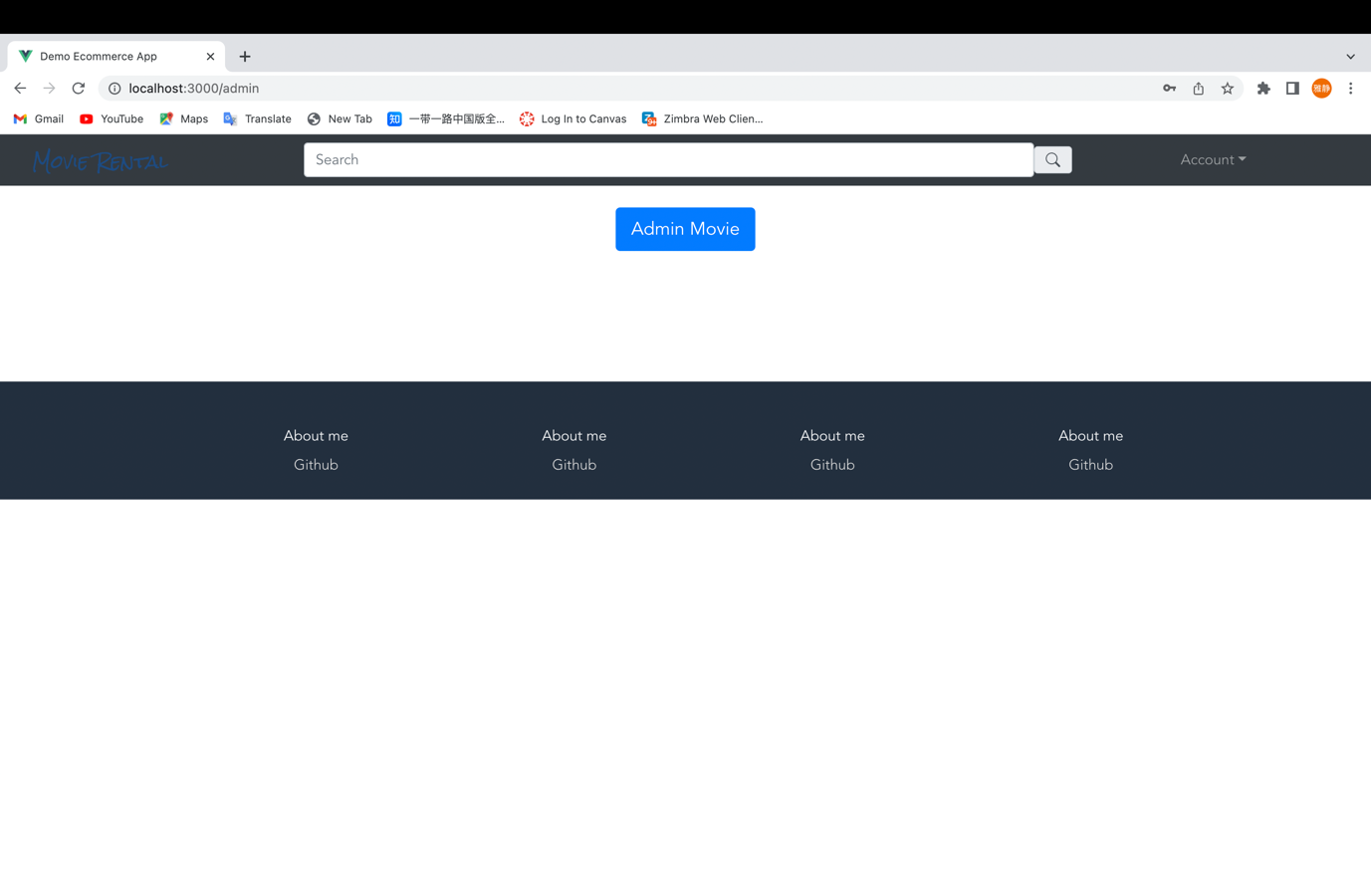

Figure 16 Admin page

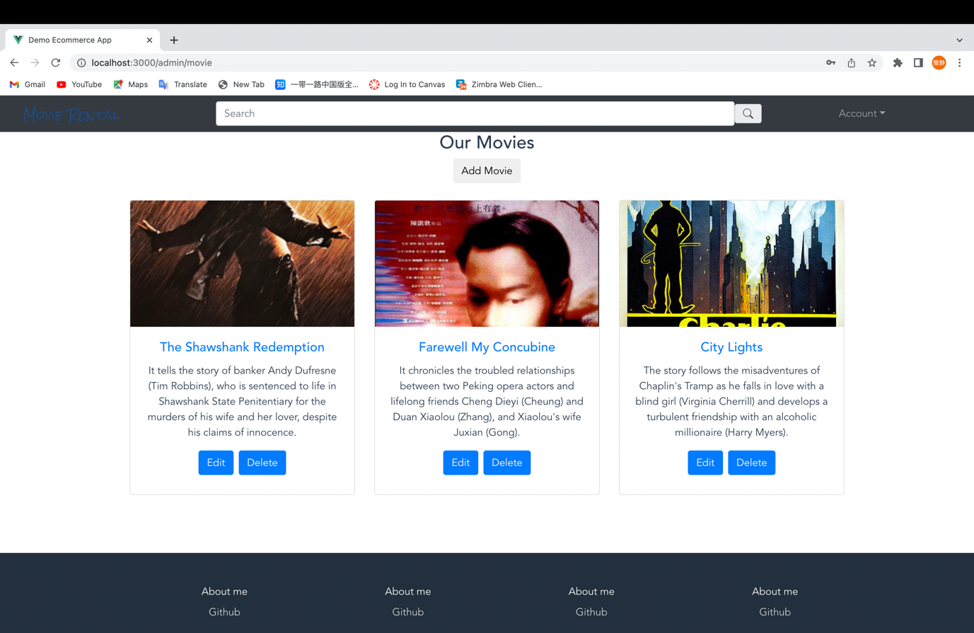

Figure 17 Movie page

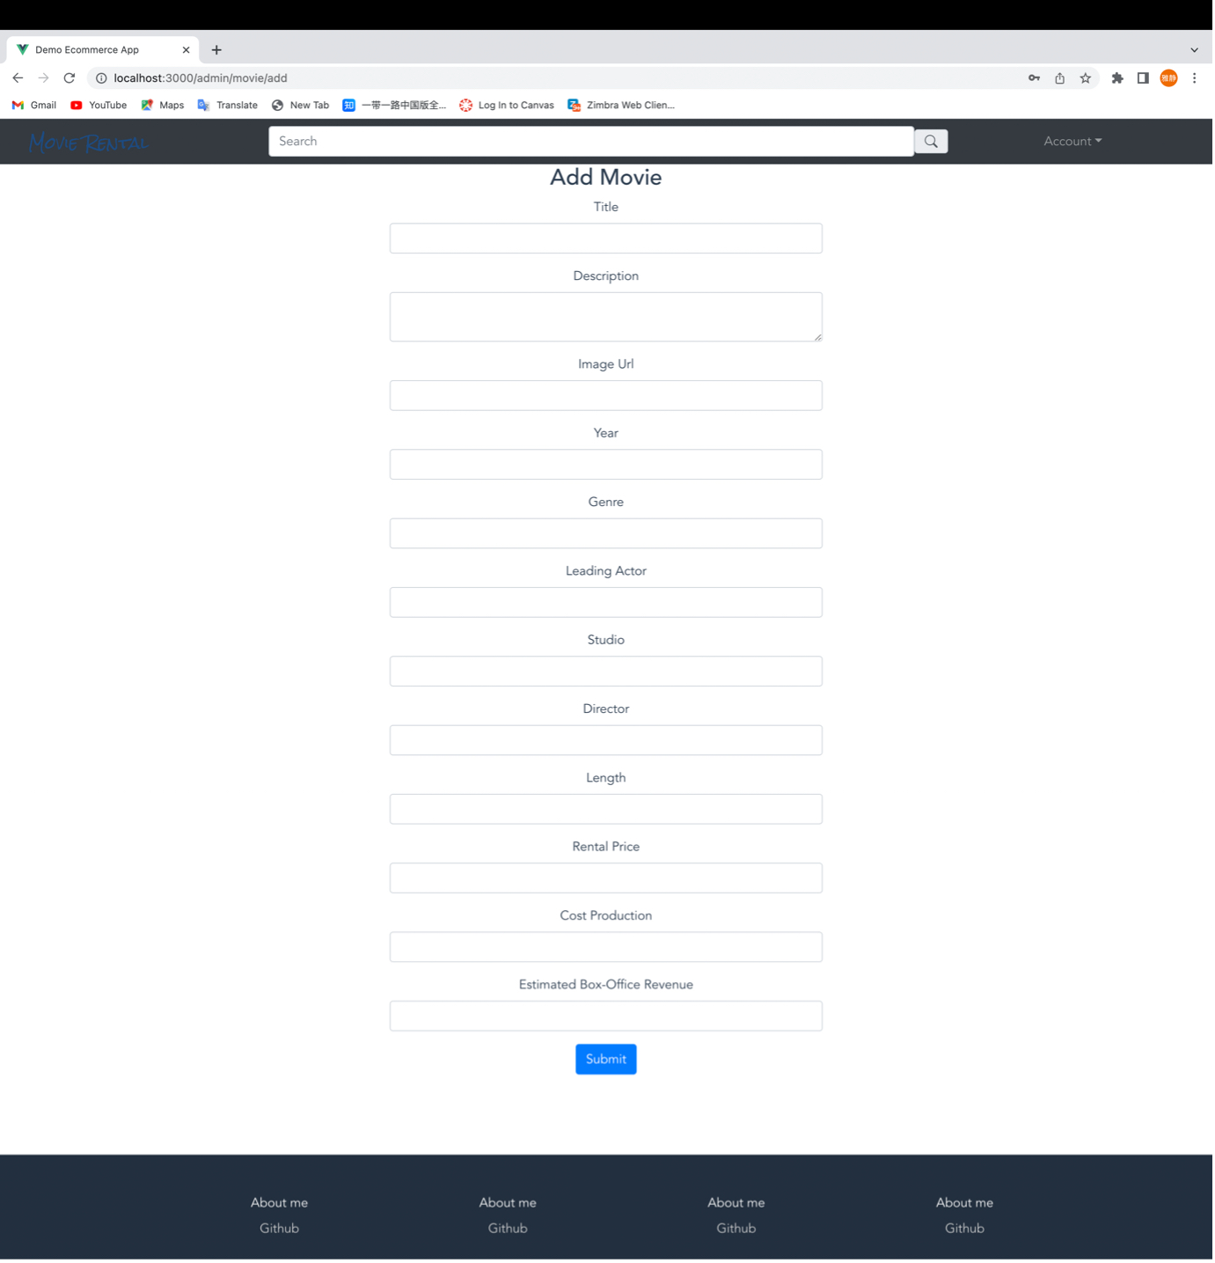

Figure 18 Add movie page

After inputting the information of the movie, user can press the submit button and then they will go to the admin movie page and see an alert (Figure 19). After refreshing the web page, the new movie can be seen in the list (Figure 20).

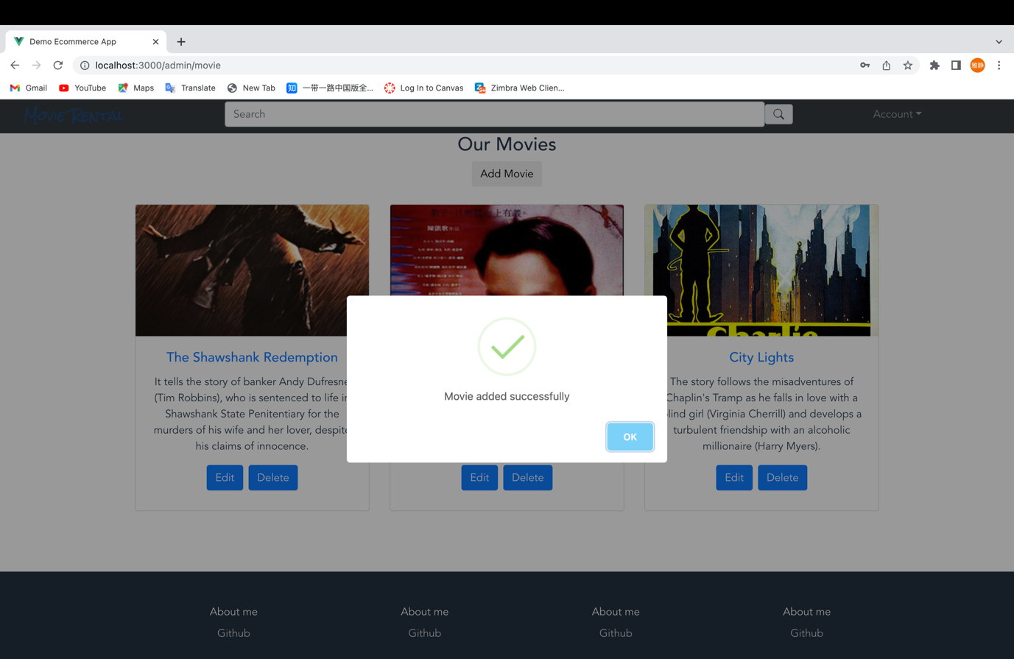

Figure 19 Admin movie page and alert

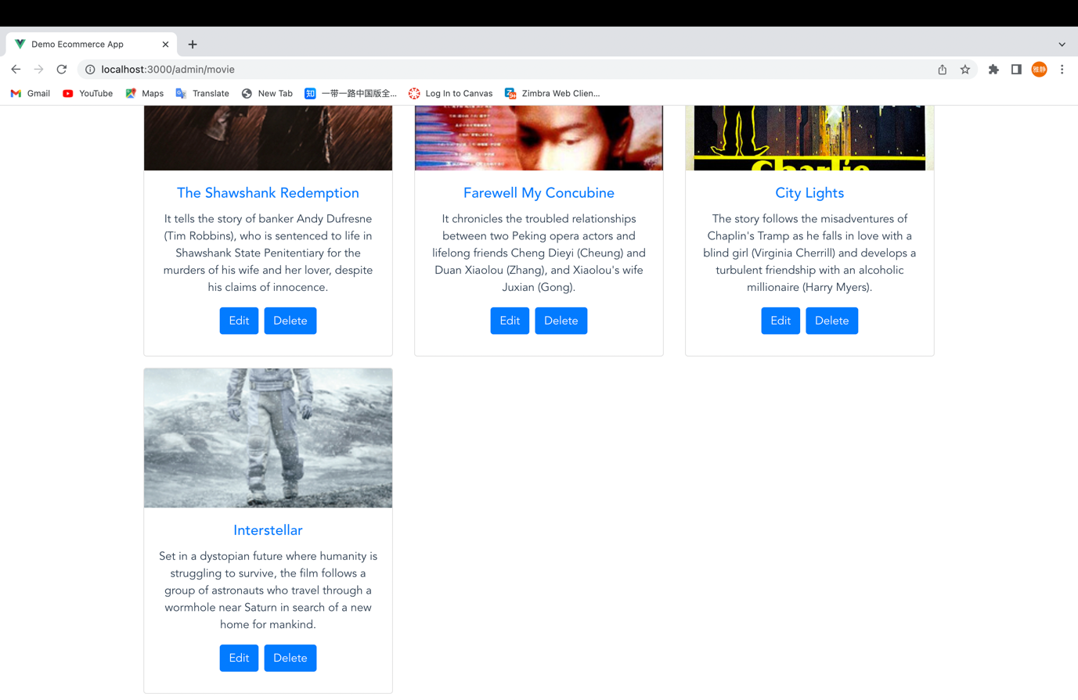

Figure 20 After refreshing, the new movie can be seen

### Edit Movie

Users can press the edit button in every movie box, and then they will go to the edit movie page (Figure 21). After editing the movie information, users can press the button ‘edit movie’ and then they can see an alert and go to the movie detail page to see the edited movie (Figure 22)

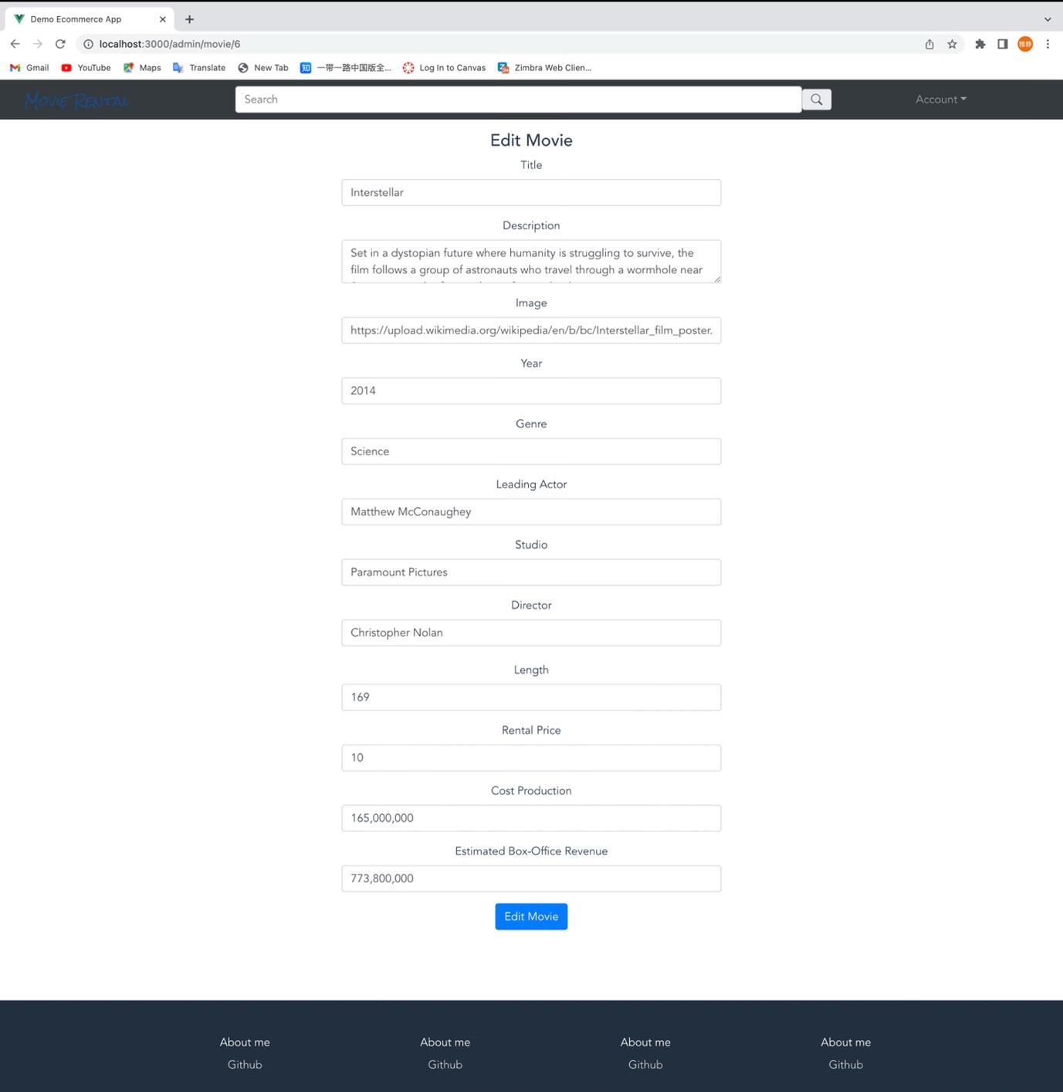

Figure 21 Edit movie page

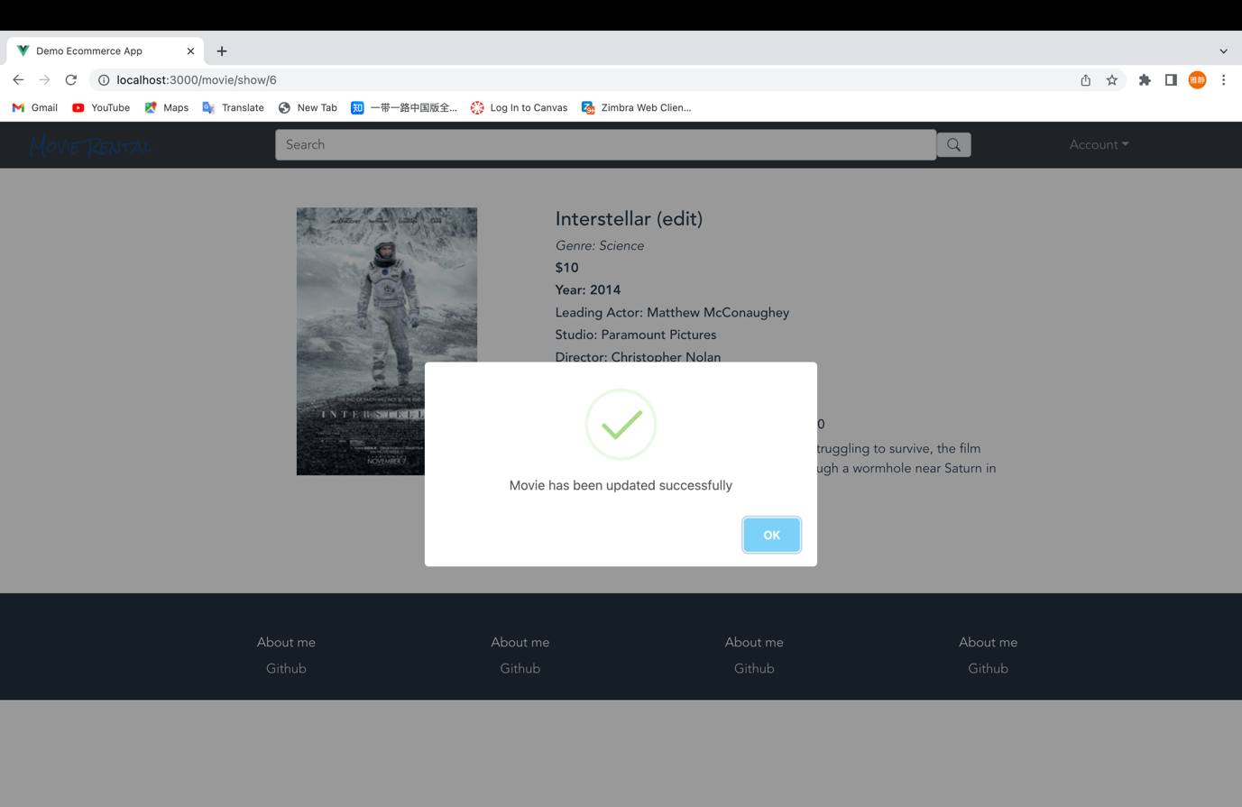

Figure 22 Movie detail page and alert

### Delete Movie

Users can go to the movie page and press the delete button in the movie box. And then they can see the alert (Figure 23). After refreshing, the deleted movie is disappeared (Figure 24).

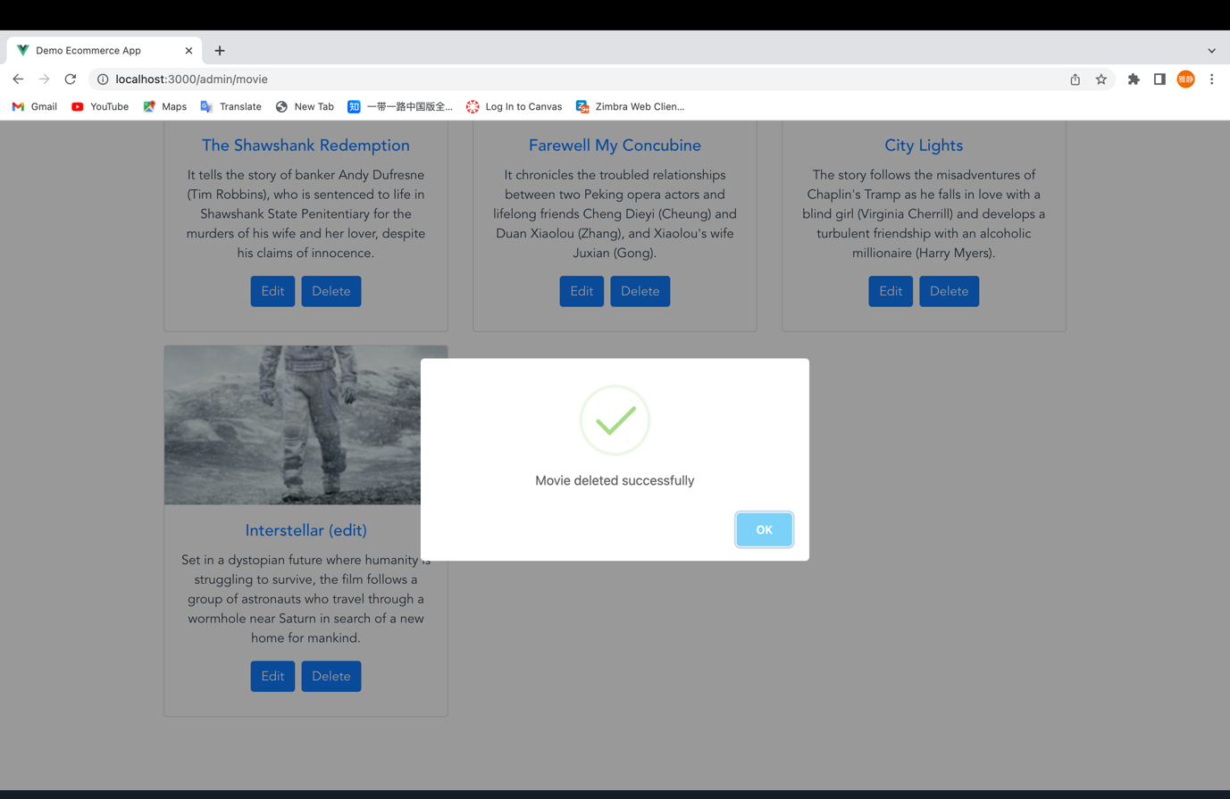

Figure 23 Delete alert

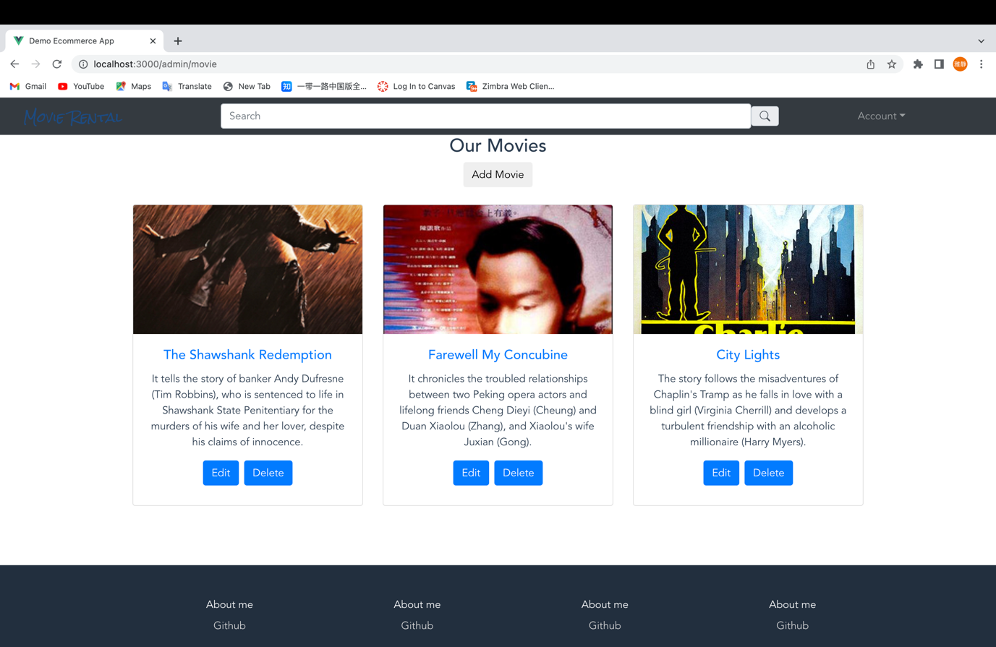

Figure 24 After refreshing, the deleted movie is disappeared

### Search Movie

Users can input the search words in the search box and then press the search button (Figure 25), and then they can see the searching results (Figure 26).

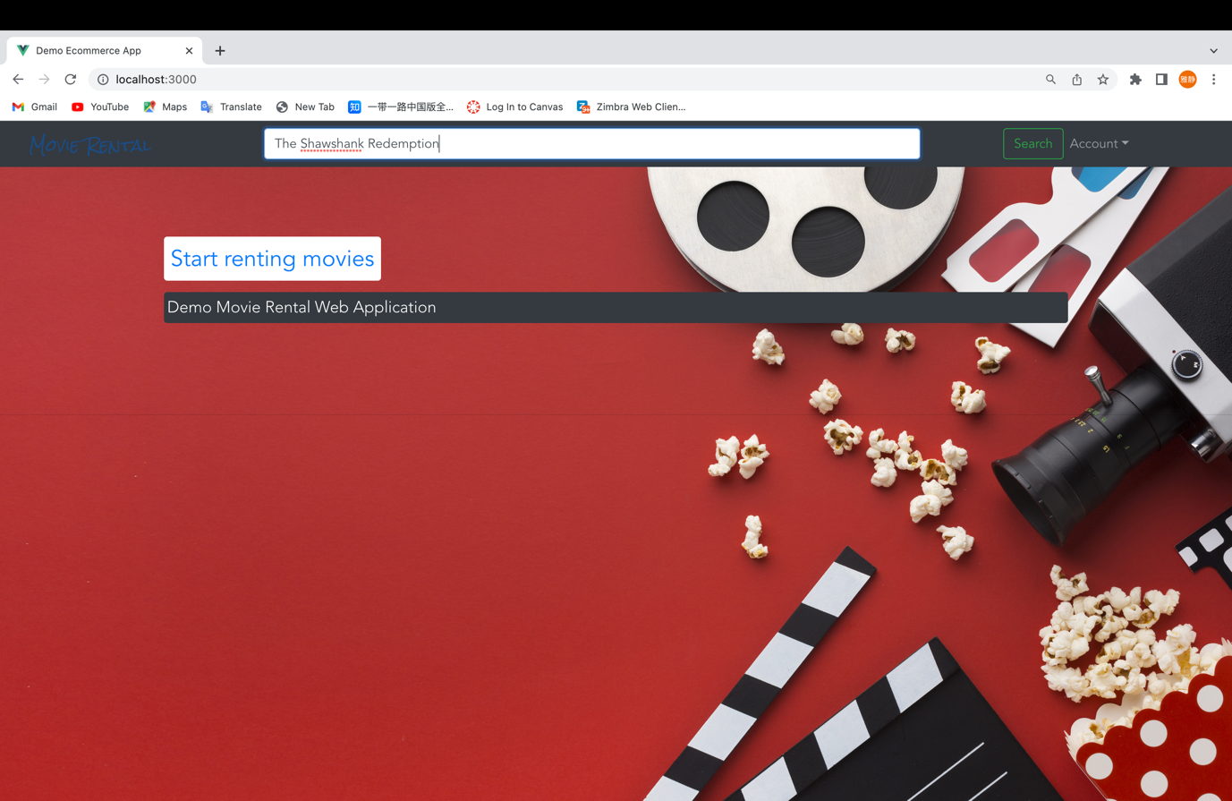

Figure 25 Input search words

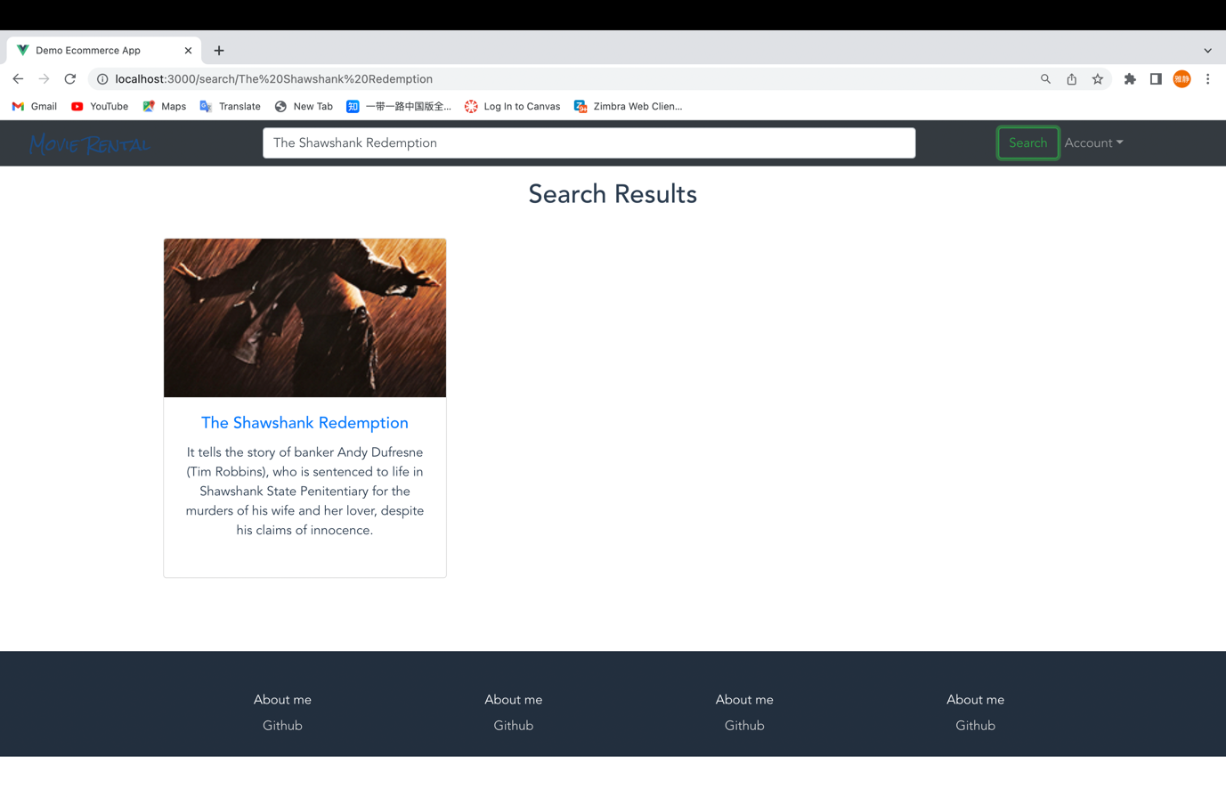

Figure 26 Search result

# Conclusion

In conclusion, this project achieves some basic functions of an online movie rental system (mainly about users and movies). In the future, more functions will be added in this project such as shopping cart and order.